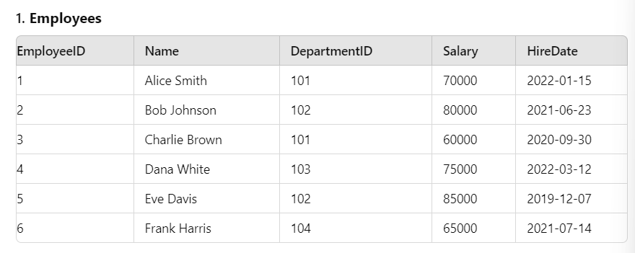

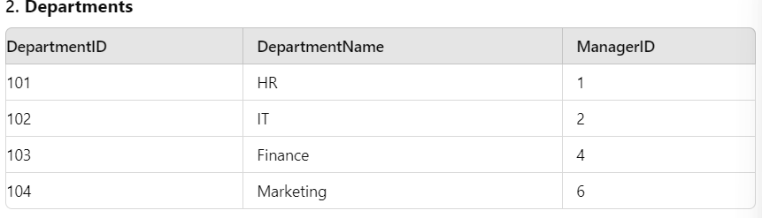

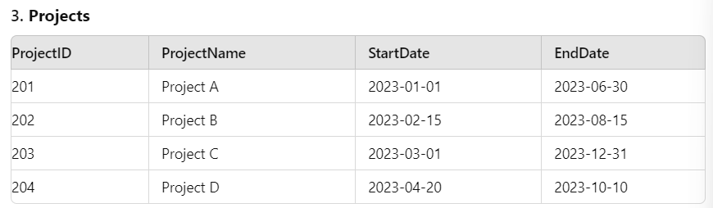

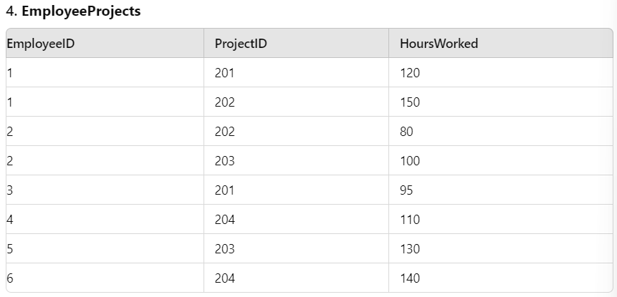

1. Total Salary of All Employees

|  |
| --- |
| OUTPUT:- SELECT SUM(SALARY) AS "Total Salary" FROM Employees; |

1. Average Salary per Department

|  |
| --- |
| OUTPUT:- SELECT d.department_name, AVG(e.salary) AS average_salary  FROM employees e  JOIN departments d ON e.department_id = d.department_id  GROUP BY d.department_name; |

1. Maximum and Minimum Salary in the Company

|  |
| --- |
| OUTPUT:- SELECT MAX(Salary) AS MaxSalary, MIN(Salary) AS MinSalary FROM Employees; |

1. Number of Employees per Department

|  |
| --- |
| OUTPUT:- SELECT NAME, COUNT(employee_id) AS number_of_employees FROM employees GROUP BY NAME; |

1. Total Hours Worked per Project

|  |
| --- |
| OUTPUT:-  SELECT p.project_name, SUM(ep.hours_worked) AS total_hours  FROM EMPLOYEE_PROJECTS ep  JOIN employees e ON ep.employee_id = e.employee_id  JOIN projects p ON ep.project_id = p.project_id  GROUP BY p.project_name; |

1. Total Salary of Employees in Each Department

|  |
| --- |
| OUTPUT:-  SELECT department_id, SUM(salary) AS total_salary  FROM employees  GROUP BY department_id; |

1. Average Salary of Employees per Department

|  |
| --- |
| OUTPUT:-  SELECT d.department_id, AVG(e.salary) AS average_salary  FROM departments d  JOIN employees e ON e.department_id = d.department_id  GROUP BY d.department_id; |

1. Maximum Salary in Each Department

|  |
| --- |
| OUTPUT:-  SELECT department_id, MAX(salary) AS max_salary  FROM employees  GROUP BY department_id; |

1. Minimum Salary in Each Department

|  |
| --- |
| OUTPUT:-  SELECT d.department_id, MIN(e.salary) AS min_salary  FROM employees e  JOIN departments d ON e.department_id = d.department_id  GROUP BY d.department_id; |

1. Total Hours Worked on Each Project

|  |
| --- |
| OUTPUT:-  SELECT p.project_id, SUM(ep.hours_worked) AS total_hours  FROM employee_projects ep  JOIN projects p ON ep.project_id = p.project_id  GROUP BY p.project_id; |

1. Average Hours Worked per Project

|  |
| --- |
| OUTPUT:-  SELECT p.project_id, AVG(ep.hours_worked) AS average_hours  FROM employee_projects ep  JOIN projects p ON ep.project_id = p.project_id  GROUP BY p.project_id; |

1. Employee and Department Details

|  |
| --- |
| OUTPUT:-  SELECT e.employee_id, e.NAME, d.department_name  FROM employees e  JOIN departments d ON e.department_id = d.department_id; |

1. Total Hours Worked by Employees in Each Project

|  |
| --- |
| OUTPUT:-  SELECT ep.project_id, SUM(ep.hours_worked) AS total_hours  FROM employee_projects ep  GROUP BY ep.project_id; |

1. Projects and Their Total Hours Worked by Employees

|  |
| --- |
| OUTPUT:-  SELECT p.project_name, SUM(ep.hours_worked) AS total_hours  FROM employee_projects ep  JOIN projects p ON ep.project_id = p.project_id  GROUP BY p.project_name; |

1. Employees Who Worked on Projects in Each Department

|  |
| --- |
| OUTPUT:-  SELECT e.NAME, d.department_name, p.project_name  FROM employees e  JOIN departments d ON e.department_id = d.department_id  JOIN employee_projects ep ON e.employee_id = ep.employee_id  JOIN projects p ON ep.project_id = p.project_id; |

1. Departments with Their Managers and Total Employees

|  |
| --- |
| OUTPUT:-  SELECT d.department_name, CONCAT(e.NAME) AS manager_name, COUNT(e2.employee_id) AS total_employees  FROM departments d  JOIN employees e ON d.manager_id = e.employee_id  LEFT JOIN employees e2 ON d.department_id = e2.department_id  GROUP BY d.department_name, manager_name; |